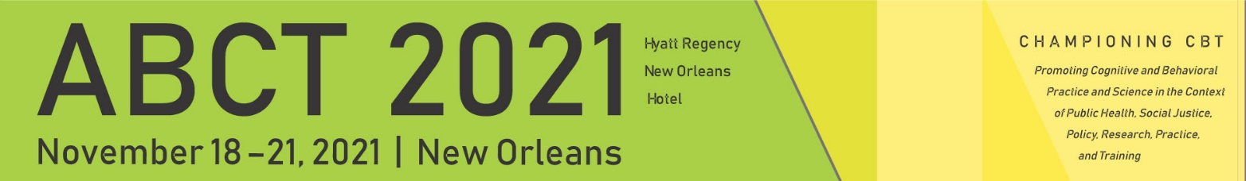
Information Required for Authors & Presenters

Symposia
- Individual Abstract Title
- Individual Abstract Keywords (up to 3 from established list; see last page on the screenshot guide)
- Individual Abstract (2200 characters)

First Author Information
  - First & Last Name
  - Email
  - Affiliation
  - Credentials/degrees to be listed in the program
  - Role (e.g., Moderator, Presenter)
  - Membership Status
  - Photo (optional)

Co‐Author Information
  - First & Last Name
  - Credentials
  - Email
  - Title
  - Organization/Affiliation
  - Photo (optional)

Posters

Co‐Author Information
  - First & Last Name
  - Email
  - Affiliation
  - Credentials/degrees to be listed in the program
  - Role (e.g., Moderator, Presenter)
  - Membership Status
  - Photo (optional)

Panel Discussions & Clinical Round Tables

Panelist Information
  - First & Last Name
  - Email
  - Role (e.g., Moderator, Presenter)
  - Affiliation
  - Credentials/degrees to be listed in the program
  - Membership Status
  - Photo (optional)

