PSYC 361
PSYCHOTHERAPY AND BEHAVIOR CHANGE
Fall 2019

Instructor Location and time
Rebecca Shiner T Th 2:45 – 4:00
Olin 106B, Phone 228-7193 Olin 104A
E-mail: rshiner@colgate.edu
Office Hours: Tuesday 10:00 – 11:30 and Thursday 1:00 – 2:30

This course serves as an introduction to psychological treatment in adults and children. We will review five major types of treatment: psychodynamic, experiential, behavioral, cognitive, and family systems. For each model of treatment, we will examine the underlying theory of personality and psychopathology, and then we will cover the mechanisms and techniques of therapeutic change. We will also examine the research evidence for the effectiveness of the models. A particular emphasis will be placed on comparison and integration of the various models of psychotherapy. At the beginning and the end of the course, we will also discuss some of the biggest issues and controversies in the field of psychotherapy: How is research on psychotherapy conducted, and how can it be improved? Should empirical research be the primary determinant of clinical practice? To what extent can people make lasting changes? Material will be presented through both lecture and discussion, and students will have the opportunity to see therapists in action, through videos.

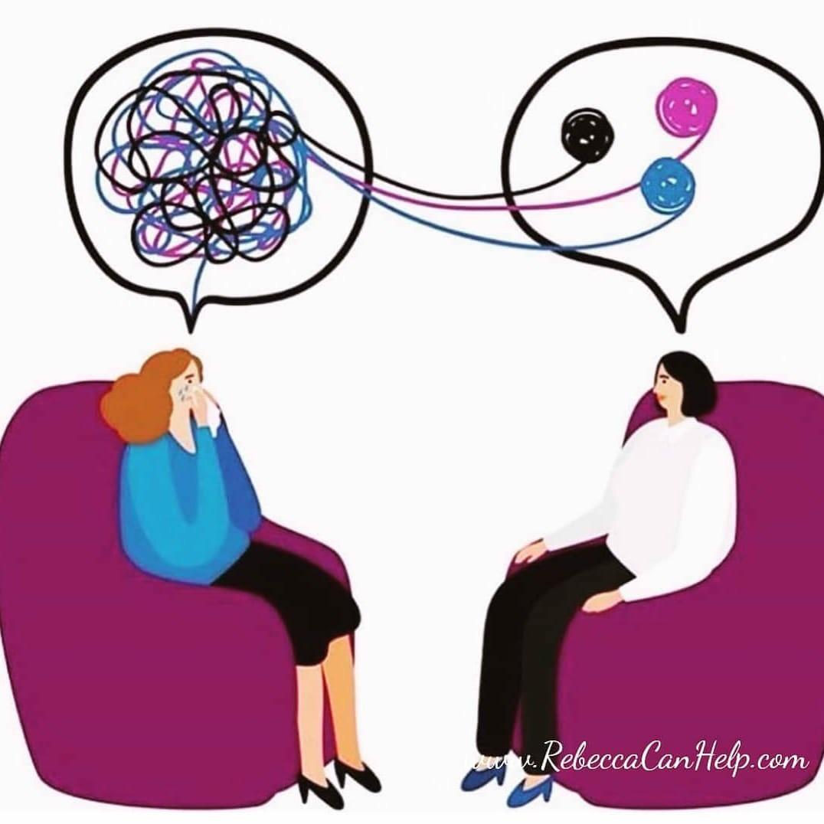

Readings

Prochaska, J. O., & Norcross, J. D. (2018). Systems of psychotherapy: A transtheoretical analysis (9th Edition). Pacific Grove, CA: Brooks/Cole. ISBN-13: 978-0190880415.

There are additional articles and chapters placed on Moodle; these are organized in the order of the class outline. The additional readings serve as a major source for class discussion and should be ready carefully. I will share links to videos to watch and current media pieces on therapy for you to read as well. After each Thursday class session, I will email you the assignments for the following week.

Course Requirements and Grading

Assignment | % of grade
Exam 1 | 20
Exam 2 | 20
Take-home final | 20
Class participation | 15
Research paper and class presentation | 25

Exams: Exams 1 and 2 will include short-answer questions and short essays. Exam 2 will be cumulative. The final exam (Exam 3) will consist of 3 take-home essay questions. The exams will include material from the lectures, discussions, readings, and videos. The dates for the exams are provided on the course outline.

Research paper and class presentation: The research paper will be a 14- to 16-page literature review of the research on treatment of a specific disorder. Details about the paper and presentation are provided at the end of the syllabus.

Class participation: Attendance is required at all classes. Class participation is a crucial element of this course, and it will make our class sessions richer, more informative, and livelier. You will be expected to have done all the reading and to come prepared to ask and answer questions about it. This portion of your grade will hinge on the quality of what you bring to our class discussions.

Journal/reflection on attempt to change: To give you some first-hand experience with attempting to make a change in your own life, we will begin the semester with a two-week exercise in which you will work on changing some pattern of behavior, thought, and/or emotion within yourself. You will be recording your plans, successes and failures, and reflections along the way. Create a Googledoc to use as your journal for this exercise and share it with me so that I can follow along.
*Tuesday 9/3: Write one single-spaced page describing the change you would like to make. Write about the pattern you want to change, why you have chosen this pattern, and what you propose to do for the next two weeks to make the change. Do not consult any resources on therapy or self-improvement as you continue this exercise. I want you to do this entirely on your own.
*Tuesday 9/3 to Tuesday 9/10: At least 2 times this week, spend some time writing about your progress thus far in making the change. At the end of the week, reflect on whether you want to modify your plan at all in a short paragraph. Complete these journals and reflections by Tuesday 9/10.
*Tuesday 9/10 to Tuesday 9/17: Again, at least 2 times this week, spend some time writing about your ongoing progress. At the end of the week, conclude by writing a single-spaced one-page reflection by Tuesday 9/17 on what this exercise has taught you about 1) what contributes to change, 2) and what interferes with attempts at personal change, 3) what you would need to do to make this a lasting change, and 4) whether you have changed your ideas about what you’d like to change about yourself.

Course Outline

TOPIC | READINGS (first author name only; full references on syllabus pp. 5-6)
Introduction  Models of therapy as worldviews  Research on therapy: How and why is it done?  Common factors in therapy  Freud: Where it all began | Yalom (1999); Text 1-4  Text 457-459; Kazdin (2000), ch. 4 and Appendix; Lee (2019); Tolin (2015); Shedler (2015)  DeFife (2011); text 4-7  Text 19-22, 25-30, 33-37, 40-41  Freud – two papers; Druss (2003)
Psychodynamic therapy  Guest Lecture: Tuesday 9/17, Steve Sandler, MD, Psychodynamic Therapy  No class Thursday 9/19 | Text 49, 61-70; Sandler (2016), chs. 1 + 2; Paul Wachtel (1994); Rodriguez (2008)
Experiential therapies  EXAM 1: Tuesday 10/8 | Text 85, 109-113, 137-138, 145-150; Pos (2007); Greenberg (2002)
Behavior therapy | Text 198-211, 218-220, 176-183, skim 221-231, 183-186; Maletzky (1994); Dimidjian (2008)
Cognitive therapy  Guest Lecture: Thursday 10/24, Matt Putts, PhD ’07, Motivational Interviewing  Third wave therapy | Text 239-242, 251-256, skim 256-263; DeRubeis (2019); Haeffel (2019)  Miller (2017)  Text 270-279, skim 280-283; Fruzetti (2019)
Family systems therapy  EXAM 2: Tuesday 11/5 | Text 289-291, 298-303, skim 309-314; Fishman (1991)

Child and adolescent treatment  RESEARCH PAPER: Monday 11/18, 9 am  PRESENTATIONS:  Tuesday 11/19 and Thursday 11/21 | Fishman (1991); Ellen Wachtel (1987); Ellen Wachtel (1994)
Final reflections  Empirically supported treatments  How can treatment reach the most people?  Adapting therapy to different cultures  Psychotherapy integration  TAKE HOME ESSAY FINAL EXAM:  Wednesday 12/18 at 9 am | Westen (2005); Goldfried (2019)  Kazdin (2011)  Cardemil (2015)  Text 8-13, 391-395; Hoffmann & Hayes (2019)

Course Policies

1. Students are expected to take the exams at the given times unless there is an emergency (death in the family, illness). You should notify me prior to the scheduled exam if you cannot make it.
2. It is expected that students will adhere to the guidelines and rules described in the Colgate Student Handbook. It is particularly important that you be careful to use your own language in all of your papers and that, when you use someone else’s language, you quote your source. Plagiarism carries stiff penalties at Colgate.
3. Students with language or learning disabilities that affect their ability to participate fully in the class or to meet all course requirements are encouraged to bring this to my attention as soon as possible so that appropriate accommodations can be arranged.

Readings Beyond the Textbook

Cardemil, E. V. (2015). Evidence-based practice in a global context. Clinical Psychology: Science and Practice, 22, 76-81.
DeRubeis, R. J., Keefe, J. R., & Beck, A. T. (2019). Cognitive therapy. In K. S. Dobson & D. J. A. Dozois (Eds.), Handbook of cognitive-behavioral therapies (pp. 218-248). New York: Guilford Press.
DeFife, J. A., & Hilsenroth, M. J. (2011). Starting off on the right foot: Common factor elements in early psychotherapy process. Journal of Psychotherapy Integration, 21(2), 172-191.
Dimidjian, S., Martell, C. R., Addis, M. E., & Herman-Dunn, R. (2008). Behavioral activation for depression. In D. H. Barlow (Ed.), Clinical handbook of psychological disorders, 4th ed. (pp. 328-364.
Druss (2003). Insight. American Journal of Psychiatry, 160, 1749-1750.
Fishman, K. D. (1991). Therapy for children. Atlantic Monthly, June, 47-81.
Freud, S. (1900/1989). On beginning the treatment (pp. 363-378), and Observations on transference-love (pp. 378-387). In P. Gay (Ed.), The Freud reader. New York: Norton.
Fruzzetti, A. E., McLean, C., & Erikson, K. M. (2019). Mindfulness and acceptance interventions in cognitive-behavioral therapy. In K. S. Dobson & D. J. A. Dozois (Eds.), Handbook of cognitive-behavioral therapies (pp. 271-296). New York: Guilford Press.
Goldfried, M. R. (2019). Obtaining consensus in psychotherapy: What holds us back? American Psychologist, 74(4), 484-496.
Greenberg, L. S. (2002). Ch. 11—Coaching for emotional wisdom in couples. Emotion-focused therapy (pp. 255-277). Washington D. C.: American Psychological Association.
Haefel, G. J., & Kaschak, M. P. (2019). Rethinking how we think about cognitive intervention for depression: A example from research on second-language acquisition. Clinical Psychological Science, 7(1), 68-76.
Hoffmann, S. G., & Hayes, S. C. (2019). The future of intervention science: Process-based therapy. Clinical Psychological Sciences, 7(1), 37-50.
Kazdin, A. E., & Blase, S. L. (2011). Rebooting psychotherapy research and practice to reduce the burden of mental illness. Perspectives on Psychological Science, 6(1), 21-37.
Lee, C. S., et al. (2019). A randomized controlled trial of motivational interviewing tailored for heavy drinking Latinxs. Journal of Consulting and Clinical Psychology, 87(9), 815-830.
Maletzky, B. M. (1994). Exhibitionism. In C. G. Last & M. Hersen (Eds.), Adult behavior therapy casebook. New York: Plenum.
Miller, W. R., & Moyers, T. B. (2017). Motivational interviewing and the clinical science of Carl Rogers. Journal of Consulting and Clinical Psychology, 85(8), 757-766.
Pos, A. E., & Greenberg, L. S. (2007). Emotion-focused therapy: The transforming power of affect. Journal of Contemporary Psychotherapy, 37, 25-31.
Rodriguez, C. I., Cabaniss, D. L., Arbuckle, M. R., & Oquendo, M. A. (2008). The role of culture in psychodynamic psychotherapy: Parallel process resulting from cultural similarities between patient and therapist. American Journal of Psychiatry, 165, 1402-1406.
Sandler, S. (2016). Tea with Freud: An imaginary conversation about how therapy really works. Dog Ear Publishing.
Shedler, J. (2015). Where is the evidence for “evidence-based” therapy? Journal of Psychological Therapies in Primary Care, 4, 47-59.
Tolin, D. F., McKay, D., Forman, E. M., Klonsky, E. D., & Thombs, B. D. (2015). Empirically supported treatment: Recommendations for a new model. Clinical Psychology: Science and Practice, 22(4), 317-338.
Wachtel, E. F. (1987). Family systems and the individual child. Journal of Marital and Family Therapy, 13, 15-25.
Wachtel, E. F. (1994). Treating troubled children and their families, Ch. 8. New York: Guilford.
Wachtel, P. L. (1994). Cyclical processes in personality and psychopathology. Journal of Abnormal Psychology, 103, 51-54.
Westen, D., & Bradley, R. (2005). Empirically supported complexity. Current Directions in Psychological Science, 14, 266-271.
Yalom, I. D. (1999). Momma and the meaning of life (pp. 53-81). New York: Basic Books.

RESEARCH PAPER

FINDING A TOPIC:

For this paper you will review and critique the empirical evidence for the efficacy and effectiveness of treatment for a particular disorder or clinical syndrome. The following is a list of possible topics:

Children and adolescents:
Anxiety (in general), or if you can find it, a specific anxiety disorder; Post-traumatic Stress Disorder; Obsessive/Compulsive Disorder; Major Depression; Disruptive behavior disorders e.g., Oppositional Defiant Disorder, Conduct Disorder, aggression; Attention-Deficit/Hyperactivity Disorder; Alcohol or Substance Abuse or Dependence; Autism Spectrum Disorder; Self-injurious thoughts and behaviors; Obesity
Adults (these sometimes include both individual treatment and family treatment):
Major Depression; Generalized Anxiety Disorder; Social Phobia; Obsessive/Compulsive Disorder; Panic Disorder; Post-traumatic Stress Disorder; Personality Disorders (or specifically Borderline Personality Disorder); Schizophrenia; Bipolar Disorder; Alcohol or Substance Abuse or Dependence (you could pick addiction to a particular drug); Anorexia; Bulimia; Obesity; Attention-Deficit/Hyperactivity Disorder; Various forms of adult antisocial behavior; Insomnia
Couples:
Couple's distress; Sexual dysfunction

Please consult with me if you are interested in another topic. I chose these topics because I am confident that there is enough empirical literature on them to make for a good paper. I highly recommend that, as you are trying to pick a disorder to focus on, you look up the diagnostic criteria from DSM-5 online; that will probably also take you to relevant background information on the disorder. Here are two useful websites: http://www.div12.org/psychological-treatments/ http://effectivechildtherapy.org/

For most of these disorders, there are many, many treatment outcome studies. In these cases, you will need to narrow down the topic in some way. You could focus on only one or two of the treatment types (e.g., only cover schema therapy or other more psychodynamic models for personality disorders), or you could focus on one particular subpopulation of people with the disorder (e.g., depression in the elderly). You could also select a focus on what is known about the mediators of progress for a certain kind of treatment. It is very important that you narrow down your topic enough so that you can provide reasonably comprehensive coverage of what is known about your topic. I want to see deep engagement with and expertise on the relevant literature on your topic, and you can only do that if you keep your focus narrow enough.

WRITING THE PAPER:

- Introduction to the paper: Begin by offering two or so paragraphs describing the key features of the disorder or difficulty in question, particularly features that will be relevant for treatment. Keep this section short. End this section with an overview of what the paper will be covering and your general thesis statement for the paper.

- Body of the paper: Review the available research literature on what treatments have efficacy and/or effectiveness for that disorder focused on whatever narrowed down question you have chosen to address. In this review, you should be attentive to the issues we discussed during the lectures on the empirical evaluation of therapy (have there been randomized clinical trials, what kind of control groups have been used, has the treatment been compared to other treatments, have treatments been used in combination, what kinds of outcome measures were used, have there been long-term follow-up studies, what kinds of patients have been included in the studies, etc.). You may include information on both individual studies and meta-analyses, if meta-analyses are available. If you are surveying a topic with relatively few studies, then you should do your best to include information on most of the relevant studies. If you are surveying a topic with many studies, you should definitely include meta-analyses.

It is very important to describe some of the key components of the treatments for that disorder and how they are presumed to be helpful to clients. For example, don’t just describe CBT in general; explain what it looks like in these particular treatment programs. In other words, a reader of your paper should have some idea what the therapy itself actually looks like. You will have to search to find more information about what that manualized treatment looks like in practice because most empirical articles give only a vague description of the treatment.

You should include the most current information on your topic. In order to start finding some of the most recent info, you might want to flip through relevant recent journals (e.g., American Journal of Psychiatry, Journal of Consulting and Clinical Psychology, Archives of General Psychiatry, Journal of the American Academy of Child and Adolescent Psychiatry, Journal of Abnormal Psychology).

Organize the body of your paper in sections with description subtitles for each section. Make the point of each section clear at the beginning, and end each section with a short summary or conclusion for that section.

- Later in the body of the paper: At some point in your discussion, describe any moderators of treatment effects, i.e., features of the disorder/ individual/family that are believed to or have demonstrated the potential to influence outcome in response to particular treatment efforts. Be sure to give the reader a sense of what it is important to know about a person (or family) with a particular condition in order to make intelligent choices about treatment.

- Conclusion of the paper: Toward the end of the paper, include your own critique of the available literature on the topic. How strong is the evidence for the efficacy of treatment for that disorder? What are the major gaps in our knowledge about treatment for that disorder? What should be the direction of future research on the topic? You should also make your own suggestions about ideas for new possible treatments for the disorder. Your suggestions can include original ideas about treatment or suggestions about how to integrate currently available treatments. This section of your paper should be at least 3 or so pages long.

NITTY GRITTY DETAILS (FORMAT + DUE DATE)

Format: 14-16 pages (excluding references), 1-inch margins, Times 12 font, double-spaced. Follow APA format.

Due dates

Tuesday 9/24 – choose a topic; be ready to list your top 4 choices at class time.

Thursday 10/17 – By class time, send me a GoogleDoc with a list of 10 APA formatted references that you have read and tentatively want to include in your paper (papers and chapters). Write a detailed paragraph explaining how you intend to narrow down your focus and what issues you will be including in your paper. Explain why you have picked this as your focus. Put a lot of effort into this—it will save you time later.

Monday 11/18 at 9 am – Send the paper to me as a GoogleDoc, and scan a document with the first pages of your article/chapters and email it to me

Late papers will be docked a grade for each day the paper is late (e.g., a “B” paper will become a “B-” if it is one day late).

CLASS PRESENTATION

On Tuesday 11/19 and Thursday 11/21, you will be doing a 10-minute presentation on your paper during class. First, you will describe how the therapy is done and the general findings on how well it works. You do not need to summarize your whole paper (e.g., you can leave out moderators/mediators). Be selective in what you present so that you convey only the key points of your paper. Second, you will demonstrate one of the techniques that works for the disorder you studied. You can demonstrate the technique in whatever way you like (e.g., have another student pretend to be a client, simply describe the technique verbally, walk us through a worksheet or two on the technique). You should bring 19 copies of a 1-page sheet summarizing effective treatments for your disorder.

