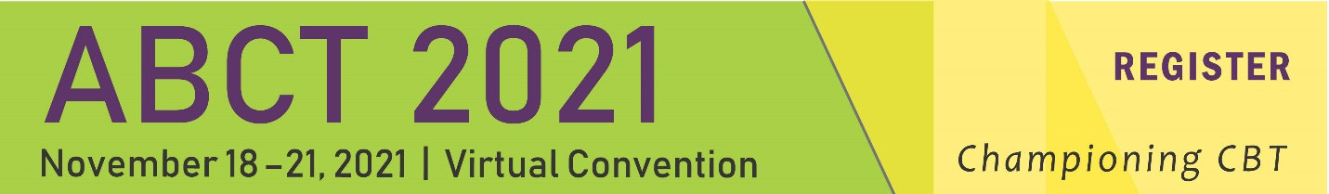

SIG Expo
- The Expo will take place on the customary date and time:
Friday, November 19 from 3:30 p.m.- 5:30 p.m. PST/6:30 p.m.-8:30 p.m. EST.
- The event will be unopposed by other convention programming except for the ABCT Awards Ceremony on Friday from 7:30 p.m. -8:30 p.m. EST.
- Each poster will be a uploaded to the Cadmium Harvester as a PDF.
- Each presenter can, optionally, record up to a three-minute audio explanation of the research, which will be posted alongside the poster PDF.
- Presenters may also, optionally, post a short abstract.
- Each author and co-author may, optionally, upload a photo of themself.
- A QR code may be used to direct attendees to handouts posted elsewhere online.
- For any questions about the poster, the author may direct attendees to social media, or set up their own individual Q & A session using the conferencing software of their choice.
- Q & A sessions could be hosted during the SIG Expo or at another time convenient to the presenter(s).
- If they use a link to another conferencing software, the presenters are encouraged to post the link for discussion on the bottom of the poster.
- Instructions regarding how to use the Cadmium Harvester will be send out to the lead presenter. The deadline date for completion of all tasks in the Harvester is Friday, November 12.

ABCT recently adopted a new, innovative poster format to increase both efficiency and effectiveness in poster preparation and communication of data. You can view the YouTube video describing the rationale for this new approach here: https://bit.ly/2Wt6I7F and find templates here:
https://osf.io/ef53g/.
Due to the virtual format, though, presenters will have latitude in deciding whether a traditional or “better poster” format will be best to convey key information. Handouts can also be posted with the virtual poster.

Setting and Materials

Posters are presented in virtual sessions within groups of similar research topics but will be available on-demand Poster Presentation Requirements:

1. For publishing purposes, the poster upload must be a PDF file at highest resolution possible.
2. The aspect ratio (ratio of width to height) should ideally be set to '16:9'
3. The complete poster is limited to one slide only. That means one single page for your PDF file.
4. Fonts should be sans-serif (e.g., Arial, Calibri, etc.)
5. Minimum font size should not be smaller than 6pt
6. Since there will not be an opportunity for live Q&A, please include your contact information so that viewers can contact you if they have questions.

Poster Content

In both innovative and traditional poster formats, it is important to provide a short, clear, non-technical description of what you did, why you did it, and what you found.
In both poster formats, sections related to a brief Introduction, a Methods section are typically included with a brief overview of such things as subjects, apparatus, or details of procedure, Results, and a brief Discussion. You should keep references and reviews of the literature to a minimum; in a few sentences (or bullet points), say what you did, why you did it and what you think it means. The format, in other words, requires you to be a bit bolder in your style compared to research reports (especially so in the innovative format), and to condense complicated events into a few short sentences. The way to think about a poster is that it is a simplified scientific report, with a discussion-oriented format. The poster should communicate the issue and conclusion, as well be eye-catching. The actual in vivo discussion should fill in the details.

Preparing and Uploading the Presentation

Your Cadmium login information can be found in your email. You will need to log in to Cadmium to upload your poster and record an audio presentation. The audio presentation can be up to 3 minutes long and is required. We recommend that your presentation include an overview of the study including the rationale key questions/hypotheses and methods, findings, and take-home points. Further instructions for recording and uploading can be found in Cadmium. All SIG posters and recordings must be uploaded by November 12, 2021. Please consider including a QR code on your poster as described here: https://bit.ly/2Wt6I7F.

Recommended Poster Format
Please find additional templates for this format here: https://osf.io/ef53g.

