SMART TRANSPORTATION OPTIONS
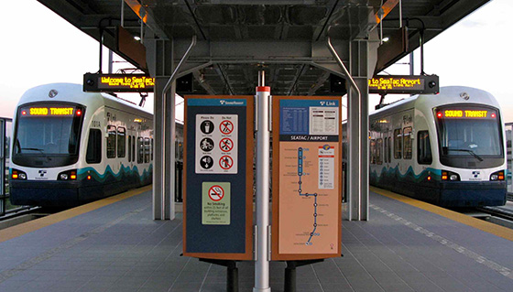
Photo: Oran Viriyincy

Link Light Rail
Sound Transit’s Link light rail makes trips from Angle Lake Station to the Northgate through downtown Seattle making 16 stops along the way, including downtown Seattle and SEA Airport. Trains arrive every 8 to 15 minutes, depending on the time of day, and take about 40 minutes to travel between Seattle-Tacoma International Airport (SEA) and Westlake Station in downtown Seattle.
Schedule:
Mon-Sat, 5:00am–1:43am (last northbound train from the airport Westlake Station departs at 11:44pm)
Sun, 6:00am–12:34am (last northbound train from the airport to Westlake Station departs at 11:14pm)
Adult Fare: $2.25–$3.50; more >>
soundtransit.org
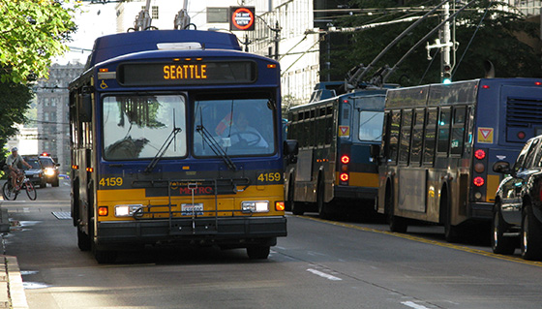
Photo: Oran Viriyincy

King County Metro Transit
King County Metro Transit provides bus service in downtown Seattle and outlying neighborhoods in King county. Download the mobile app for on-the-go transit information, available for iPhone and Android.
Schedule:
Timetables and route maps can be found on the King County Metro Transit website.
Adult Fare: $2:75–$3.25 (ORCA cards); more >>
kingcounty.gov

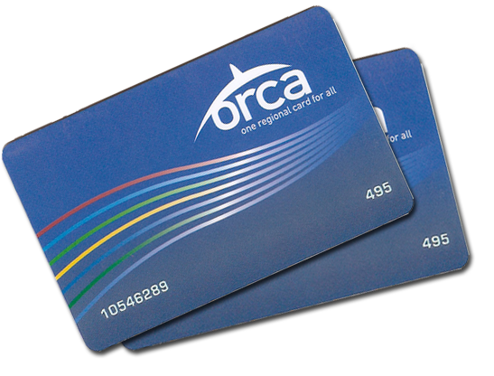

ORCA Cards
These transit passes can be used on streetcars, light rail, buses, and more. ORCA cards cost $3; load an all-day regional transit pass onto an ORCA card for $8. Transit pass value covers $3.50 per ride.
orcacard.com
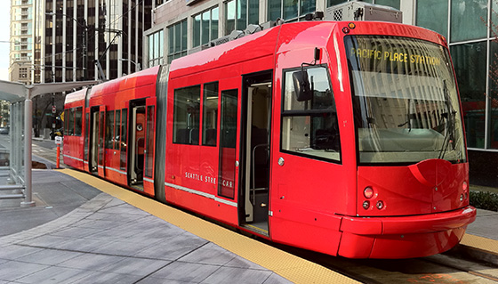
Photo: Richard Eriksson

Seattle Streetcars

South Lake Union:
The line connects the South Lake Union neighborhood to Seattle’s vibrant downtown core, consisting of 1.3 miles, nine stops, and full of shops and restaurants as well as Lake Union’s 12-acre waterfront park.
Schedule:
Mon-Thu, 6am-9pm
Fri-Sat, 6am-11pm
Sun & Holidays, 10am-7pm
No service on Thanksgiving and Christmas Day

First Hill:
This line consists of 10 stops and stretches 2.5 miles, connecting to Link light rail at the Capitol Hill and International District stations, the Sounder Commuter Rail and Amtrak intercity rail at the King Street Station, and Metro Transit buses at several points.
Schedule:
Mon-Sat, 5am-1am
Sun & Holidays, 10am-8pm
Adult Fare: $2.25 (coins, credit, ORCA cards); $4.50 (all-day pass); more >>
seattle.gov/transportation/getting-around/transit/streetcar

GET TICKETS VIA A MOBILE APP
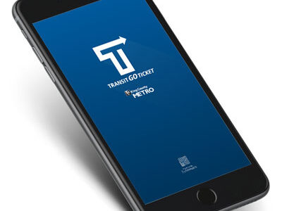

Download mobile app Transit GO Ticket to purchase digital tickets for King County Metro Buses and Water Taxi, Sound Transit Light Rail and Sounder, Seattle Streetcar, and Kitsap Transit. The app is available on the Apple Store and on Google Play.

••
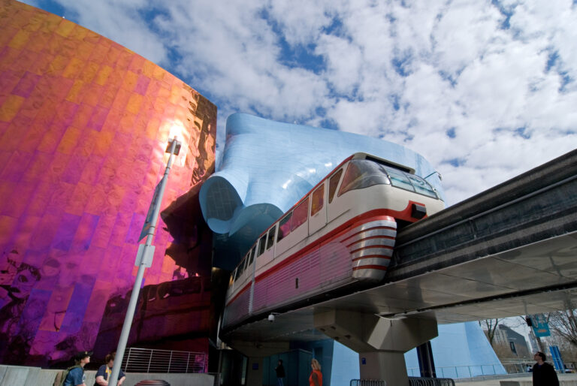 Photo: Howard Fisk

Seattle Center Monorail
The iconic Seattle Center Monorail travels between Westlake Center in downtown and Seattle Center at the base of Queen Anne hill. Regular operating hours are between 7:30am and 11pm, Monday-Friday, and from 8:30am to 11pm, Saturday & Sunday. Trains depart every 10 minutes and the trip takes only 2 minutes each way. One-way fare for adults is $3.00. Schedules, information and FAQs are on the Seattle Center Monorail website.
Schedule:
Mon-Fri, 7:30am-9:00pm
Sat-Sun, 8:30am-9:00pm
Fare: $3.00 (one way; ORCA cards accepted)
seattlemonorail.com
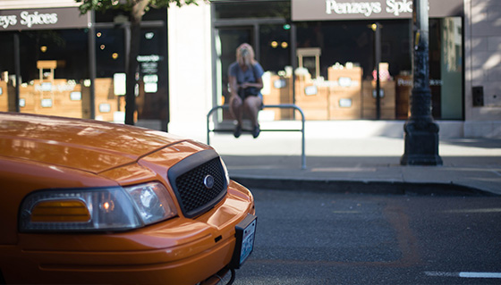
Photo: Nicola

Taxis, Limos, Town Cars & Ride Sharing
At SEA Airport, taxis and ride-sharing companies are available on the third floor of the parking garage. One-way rides between the airport and downtown range from $40-$55. To arrange for a limo, town car or taxi ride in advance, use any of the travelers’ information boards in baggage claim or visit the ground transportation information booth on the third floor of the parking garage. Contact our concierge team at the Seattle Visitor Center for referrals for specific transportation companies based on your personal travel needs.
In downtown Seattle, Lyft, Uber, and metered taxis offer in-city transportation from local drivers. All rides can be scheduled using smartphone apps.

Courtesy Silvercar

Rental Cars & Car Sharing
All car rental companies providing service at SEA Airport are located in the off-site car-rental facility. Dedicated shuttle buses run 24/7 to pick up passengers outside baggage claim at the north and south ends of the main terminal. If you prefer to enjoy the city using public transit when first arriving, car rentals are available at multiple downtown Seattle locations. Ask our Seattle Visitor Center team for referrals or assistance.
Visitors can rent vehicles by the hour from Zipcar or by the minute from GIG Car Share.

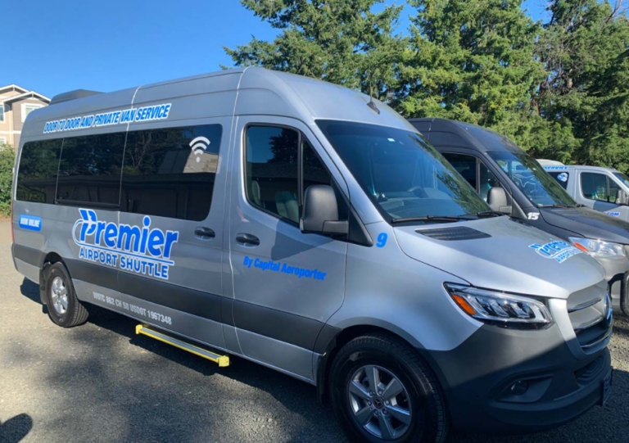 Courtesy Premier Airport Shuttle

Shuttles & Courtesy Vehicles
Ride-share, door-to-door vans, and airport shuttle services are available to passengers at the Ground Transportation Plaza on the third floor in the SEA Airport parking garage. Premier Airport Shuttle Seattle offers shared and private shuttle service starting from $33 per person to Downtown Seattle hotels and also offers regularly scheduled Seattle cruise ship transfers. Hotel courtesy shuttles pick up and drop off passengers on the 3rd floor of the airport parking garage at Islands 1 & 2.
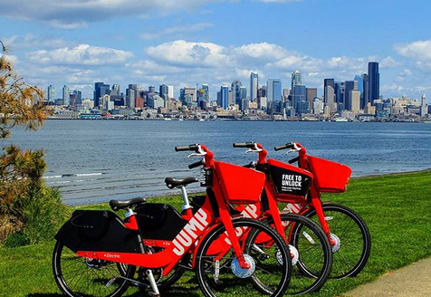
Courtesy @pinay_shortie

Bike & Scooter Sharing
Seattle is a bike and scooter-friendly city. If you’re visiting, it’s easy to find a ride no matter where you are. Open your Uber app and select the ‘2-Wheels’ option from the top menu to quickly and easily reserve a nearby Lime bike or scooter for $1, plus varying rates per minute. All rentals are dockless and include an electric assist that provides a boost up to 15mph. Or try VEO‘s Cosmo-e bike, suitable for a range of physical abilities and preferences. The Cosmo-e provides users with the option of pedaling or using the throttle to get where they need to go.
Electric scooters also dot the streets of Seattle, adding an alternative way to move through the city. Keep an eye out for options from Bird, LINK, WHEELS, and SPIN to enjoy this unique app-based mode of transportation.

Kristin Gillespie

Travel by Rail
Five train routes service Seattle’s King Street Station, just south of downtown. Sound Transit’s Sounder commuter train spans Everett, north of Seattle, to Lakewood, south of Tacoma. Amtrak has three routes: Coast Starlight travels between Seattle, Portland, and Los Angeles. Amtrak Cascades travels between Vancouver, BC; Seattle; Tacoma; Portland; Salem; and Eugene. Empire Builder travels between Chicago; Minneapolis/St. Paul; Spokane; Portland; and Seattle. Rocky Mountaineer offers a high-end travel option between Seattle; Vancouver, BC; and the Canadian Rockies.

